Blockchain: the impact on banking
managing the emergence of Blockchain applications

Brian Lilley
Dept. of Computing and Technology
Staffordshire University
College Road
University Quarter
Stoke-on-Trent
Staffordshire ST4 2DE
Brian.lilley@bcs.org.uk

Abstract — Blockchain is an Emerging Technology, driving radical innovation with significant potential disruption to traditional banking models through a myriad of innovative applications. Most notable being the Crypto Currency - Bitcoin. Bitcoin is one of the first to market Blockchain applications, demonstrating general acceptance & creating significant interest and excitement in Blockchain as a foundational technology for profound game changing applications. This paper is intended to provide analysis of blockchain applications in general terms of a distributed ledger & attempts to identify perceived challenges/gaps in the context of financial services and proposes opportunities for further research & development within traditional organisations to ensure they remain relevant, competitive and value add.

Keywords - blockchain; emerging technology; crypto currency; bitcoin; application; banking; regulation

Introduction
Hype or not, Blockchain application in the form of Bitcoin demonstrates potential significant impact to traditional banking by solving one of the key problems of providing trust between the actors in the exchange of value, without the need for an intermediary broker. Traditionally, banks have fulfilled the role of ‘intermediary broker’ by providing centralized ledgers & brokers of trust for many years.

Blockchain provides a de-centralized 'Immutable' ledger, open to multiple participating parties collaborating without having to trust each other [1].

In the example of Bitcoin crypto currency, the ledger is held on a decentralized network of some 6000 computers globally. The ledger is updated every 10 minutes with a new block of transactions [1].

The decentralized network of computers competing for the rights to update the ledger. They compete using compute energy. That is- the transactions are passed through a compute intensive mathematical algorithm. The first computer to complete the computation wins the right, and earns small amounts of the crypto currencies. The integrity and authenticity of the data processing and answer claimed by the winning computer is validated by the other computers in the network.
To subvert the transactions would require immense compute power not just to subvert the one transaction, but also to continue subverting further transaction writes in order to 'keep the lie alive'.
The more processing power invested by the 'miner', the more chances it has of winning the right to update the ledger and earn, 'mine' crypto coins.

Each transaction entry in the ledger leverages hashed algorithms to store data and includes data from a hash of the previous entries to provide a chain of trust from entry to entry. The inherent trust is what traditional banks (driven by regulation and law), would have provided as the intermediate man in the middle. Bitcoin is an example of an application of Blockchain – a simple currency exchange mechanic not backed by government or any one institution.

Understanding the Emerging Technology ‘ET’ characteristics of Blockchain will help to provide a metric for scoring and weighting elements of Blockchain itself, and of the innovation it is expected to realise. This paper provides a general definition as well as discussion of the ET aspects of Blockchain, highlighting some of the characteristics pertaining to Blockchain applications in the banking landscape, and focus on the crypto currency application - Bitcoin in order to demonstrate how innovation founded on emerging technology itself can be regarded as an emerging.

Through an understanding of its maturity & adoption cycle of Blockchain applications, the paper will attempt to conclude with identification of a sample of the challenges and gaps as they develop into generally accepted technology, a currency for example, and how some applications may disrupt centuries old value exchange mechanics, raising ethical questions around how they are governed, and their impact on society.

1.1 Rationale
The rationale is to help financial services organisations understand Blockchain applications and navigate the expected disruption to traditional banking practices. That is, to provide insight into what effect Blockchain & Crypto currencies will have on traditional banks, and how those banks need to engage in emerging tech generated by Blockchain apps in order to identify where they might provide value-add services in news ways as well as exploit opportunities with their traditional expertise – e.g. regulatory compliance, cross selling of other financial services, customer relationships, wealth management, Investment expertise and perhaps even bricks and motor buildings where people have trust.

Definition of an “Emerging Technology”

Even the term Emerging Technology is still emerging. As more literature on topic is produced, multiple versions have been offered, but still without a specific definition being widely agreed upon. The following table has the key elements common across many definitions and is sufficient to address this papers’ requirement in demonstrating key characteristics of Blockchain and its applications as they emerge. Table detailed in the Journal of Technology Management and Innovation, 2013 Volume 8, Issue 3 [2].

Table 1. Typical characteristics of an Emerging Technology
Characteristics | Description
ET uncertainty | The uncertainty associated with ET takes several forms with un- known and unpredictable values and outcomes, such as standards and specifications (maturity), business models, price, and adoption rate uncertainties.  As time passes, the ET becomes more matured and diffused and the number of adopters increases while costs drop. In contrast, ethical and social concerns might increase as ET is used in new applications.
ET network effect | The value of an ET increases by increasing the number of ET users.
ET costs | The cost of owning the ET is high, and the cost of substituting traditional technology with the ET is high.
Unobvious ET impact | The social and ethical impacts associated with the use of ET are unseen, unknown, or unexpected before its adoption/use or at an early stage of the ET life cycle.
ET is limited to creator or inventor country (availability of ET) | ET is usually available for use in a particular context or in the country that creates or invents it.
ETs are not fully investigated and researched | Most of the materials on ET are white papers and technical reports produced by the manufacturers of the ET with little scientific/academic research.

The overall intention in [2], is to provide the beginnings of a framework for understanding where those technologies sit in terms of ‘emergence’, and the types of elements that would need to be managed. Example – “...business models, price”. As the blockchain application matures, how does a bank monetize the application if their key traditional models have been marginalised. Detail is given of papers offering approaches to analyzing maturity through quantitative analysis through literature analysis.

A deeper look: Its more about Blockchain than Bitcoin

In 2015, an article on the website Coindesk [4], stated that eight of the largest financial services institutes in the world had made statements that they had started, or were starting initiatives in Bitcoin / Blockchain technologies, and that they saw significant potential impact on Financial services. Some of those organisations stated that perhaps the Crypto Currencies may be regarded as commodities rather than as replacement to traditional FIAT currencies [6]. Instead, the view was rather that the underpinning technology of Blockchain was what contains considerable potential for much more profound impact on financial services.

The Coindesk web article [4] demonstrates a key characteristic of the emergence of a technology - Uncertainty. Even though the Bitcoin application itself shows elements of maturity in some of the ET characteristics, (example ‘network effect’ - more users using it making the demand drive its value as a currency rise significantly & demonstrating ‘general acceptance’), the underlying protocol and other applications, still in the R&D phase are thought to be the more potentially impactful. To further highlight the uncertainty of Blockchains first major application (in its current state), is a further article only two years later stating significant concerns around Crypto currencies. https://www.coindesk.com/ubs-cio-arent-getting-involved-bitcoin/ - "All it would take would be one terrorist incident in the U.S. funded by bitcoin for the U.S. regulator to much more seriously step in and take action. That's a risk, an unquantifiable risk, bitcoin has that another currency doesn't." [4]

Blockchain is regarded as a potential disruptor of many industries. Alex Tapscott, TEDx San Francisco describes: ‘Blockchain is disrupting the disruptors’ [5]. A direct reference to the key benefit of Blockchain - instantiating trust and how connecting consumer to consumer directly changes the game. Tapscott states “Traditionally, banks support currencies through manufactured trust intermediaries. Providing a brokering service of those looking to trust, and those looking to be trusted.”. This is in contrast to the traditional approach of trust but verify through slow intermediaries. The value add of the intermediary is establishing the identity of the parties. Tapscott continues to summaries that we live today with a 'trust gap' which those intermediaries fill which makes some financial services exclusive, that is - some people do not have access to banking/transaction/ transfer services. Crypto currencies changes that significantly.

Gartner states blockchain is at its peak of hype and forcing CIO’s to take notice.

Gartner “Having a grasp on the economic potential for blockchain is essential to better analyze investment spend and prioritization, by industry and geography. As with many prior emerging technology enabled changes, the "s curve" of growth is quite pronounced, and this Trend Insight Report offers Gartner clients a forecasting tool that will help them to better understand the impact on their business” [7].

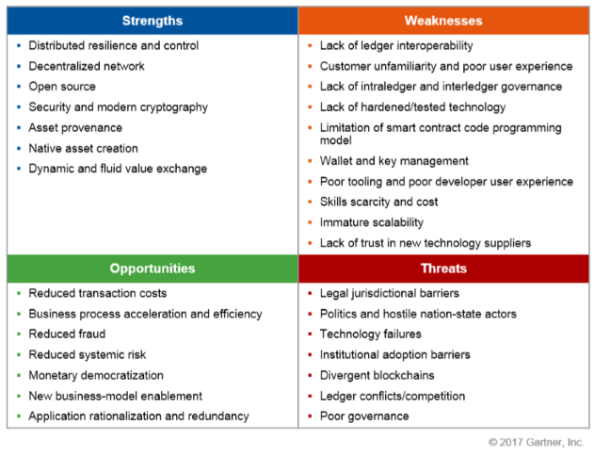
Figure 1 - SWOT analysis on Bitcoin application of Blockchain. [7] Gartner, March 2017

Impact of Blockchain on banking

Its all about trust! Blockchain provides trust directly between parties which was traditionally the role of the bank. This removal of the middle-man is sometimes described as “disintermediation”. This innovation in trust that has potential to disrupt any organisations where value is to be exchanged between parties. In addition to banks, consider organisations such as Uber or AirBnB where consumers can connect directly with each other with trust baked into the blockchain.

The significance of Trust is described by [x]Richie Etwaru. TedxMorristown. Blockchain: Massively Simplified, as he defines Trust from Blockchain as filling the next major gap.

Etwaru proposed:
Knowledge (Printing press 1400s)
Power (The engine 1800s)
Distance (The Internet 1900s)
Trust (Blockchain 2000's)

The element of trust will prove profound in the enablement of new services and value propositions. From a banking perspective, these services will be both complimentary & competitive to the core business. There is a lot of uncertainty associated with Blockchain and a lot of claims. Either way, the bank needs to ensure it has the appropriate R&D, vendor & market analysis in place to ensure it maintains competitive advantage or at the very minimum competitive equality. Perhaps in some cases, even survival.

Here is an example of predicted upside with Blockchain from Gartner report - Practical Blockchain: A Gartner Trend Insight Report [7]

■ By 2022, at least one innovative business built on blockchain technology will be worth $10 billion.

■ By 2030, 30% of the global customer base will be made up of things, and those things will use blockchain as a foundational technology with which to conduct commercial activity.

■ By 2025, the business value added by blockchain will grow to slightly over $176 billion, then surge to exceed $3.1 trillion by 2030 (see Figure 4).

Gartner report ‘Practical Blockchain: A Gartner Trend Insight Report’. March 2017. Authors David Furlonger, Ray valdes [3]

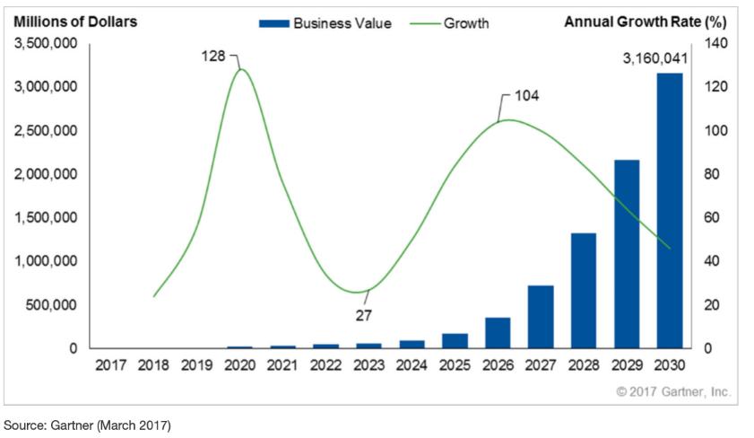
Figure 2. Gartner predicted trends on Blockchain application growth

Key opportunities for banks: How to identify them and how to leverage them.

Blockchain has many possible applications relevant to banking. Anywhere where there is paperwork, there is an opportunity to reduce operational costs as well as provide additional value-add services. For example – Smart Contracts, where enforcement is inherent in the chain, through transparency & non-repudiation, or Trading systems where assets distributed globally can be tracked and exchanged on a public ledger: wherever there is paper work, or value, the complexity of tracking/auditing/securing is addressed by a chain of immutable & trusted transactions. Remember that a facit of Blockchain is disintermediation – thus, the CIO of the bank must approach delivery of such services to its customers with care. That is, the bank needs to ensure that its services are still key value adds to the customer providing assurance & insurance for the customer, ultimately providing trust for the customer.

Gartner: “CIOs have a role to play in providing guidance in business language that allows the risks and opportunities to be properly understood. Because blockchain is not a tactical response to a standard technology problem, clear strategic foresight must be developed — and often enhanced with multiple business-use-case proofs of concept (POCs). CIOs that invest in studying and experimenting with this emerging technology will be in a better position to address their boards and senior executives with greater clarity and with a stronger fact base” [7]

Table 2 - applications / opportunity of blockchain for banking includes the following:
Application | Opportunity
Provenance of assets. | Deliver a service for physically securing assets but also digitally signing the blockchain as having witnessed the asset inventory
Securities Settlements | Handling the legal & compliance requirements and digitally recording in private blockchains.
Records management | Traditional paperwork storage through private blockchain and into public blockchain
Cost Reduction | General cost reduction for any elements of reconciliation either intra or inter-bank
Cash flow | Cost reduction for cash flows intra or inter bank
Lower Transaction costs | Cost reduction in transaction costs internally as well as for customers
Blockchain hosting | Hosting private blockchain applications for equity trading
Blockchain hosting | Hosting private currency exchange / currency commodities. Add value to public crypto currencies or processes by providing traditional services – legal, regulatory, insured etc.
Currency banks | Hosting secured storage of Crypto Currency. Traditional banking asset handling combined with new world trust models: Escrow service for secure ‘bit bunkers’
IPO paper trail & share cert handling | Document storage - Share Certificates, Share transactions. Wrapping those private chains with legal expertise, governance and regulatory compliance services

Key challenges for banks & how the CIO should address
Worst case scenario? The threat of total disintermediation from the implementation of a decentralized, distributed public network that renders the traditional centralized banking model irrelevant! At time of writing, many blockchain applications are simply conceptual or just not fully developed nor have been proven to work at scale. The technology is still emerging. There is time for the CIOs to act, and act they must.

There is significant risk in adopting early and significant operational risk will exist for several years as products mature and the vendor space and ecosystems develop. The CIO needs to mandate an approach within the organisation to ensure the right behaviours to understand the challenges and ensure the appropriate proactive initiatives and reactive responses.

The CIOs must educate themselves and the executive board of directors to ensure the initiatives and responses have the business priority & funding required. The mandate from the CIO must run through all elements of the business to ensure sufficient grounding to deal with the evolution/revolution coming and instill the measured response of risk v benefit. There is a clear need for training at all levels, most importantly for the research and development to understand the impact to the current business model as well prototyping future models and supporting technologies. Supply Chain & product managers must work closely to select the strategic vendors to roadmap the future and make the appropriate selection. The firm should partake in membership of bodies attempting to standardise this space as this will provide an insight into trends, concepts and technology capability amongst its peers.

Overall, the costs must be balanced against the risk. Prototyping solutions, driving projects must do so with the understanding that they should fail-fast, and that the primary outcome is to ensure the appropriate use cases and navigate with steps to new technology end-states.

Below is a sample list of some of the challenges to the CIO along with proposed responses/initiatives

Table 3
Challenge | Response
Blockchain applications, example – ‘Bitcoin’ are not user friendly. Standards  Unknown to the consumer, that is - no perceived ownership or governance | Here is where traditional banks can provide value add by wrapping public services with their own expertise and services. There is opportunity to build centralised service upon decentralised network. E.g. a private currency exchange, or private document storage mechanic based on blockchain. Permissioned services around a permission less system.  The banks may even provide these services as baby steps to an end-state where the public service has all of the issues around governance addressed.
Power issues related to blockchain processing | Grid compute – Advanced datacentre hosting in cold climate reducing HVAC.
Immature vendor ecosystem. Many start-ups & consortia competing for market space where little understanding of standards, legality & legitimacy. | Maintain partnership with strategic vendors. Partake in steering groups and peer consortia.
Many blockchain technology and foundational concepts are immature, poorly understood and unproven in mission-critical, scaled business operations. Blockchain technology has operated outside traditional legal, accounting and institutional governance frameworks, threatening traditional banking. | Maintain overall long & short term strategies and be prepared to build value-add solutions for intermediate stages in the emergence of blockchain applications. Understand where technology is compliment of compete. Be prepared to fail-fast.
Sheer volume of noise: New product Hype, standards, consortia, proof of concepts, proof of technology | Leverage Research firms to appraise the landscape on 6 monthly basis, bibliometric analysis, peer groups. Maintain measured response – cost v benefit
Architectural choice of internal/external | The key to blockchains proposed significant disruption is trust between parties (public realm), without a common intermediary. The assumption is that that network will be a public one, which entails significant challenges around legality, legitimacy and governance. Banks must understand whether their systems will partake in public or private, or potentially some hybrid whilst the technologies mature
How will blockchain usage impact the enterprise's risk policies and procedures (as well as the implications for legal and regulatory guidelines and rules | Internal Risk & compliance practices must be educated in Blockchain and also partake in prototyping exercises from the outset and take part in the industry peer working groups & forums,
Are the right skills in place to consider blockchain development and deployment?  Does the organisation have the right training? | CIO should mandate appropriate training investment & process throughout the organisation. Training and prototyping should be
Are people enabled to prototype blockchain applications and fail fast | CIO needs to ensure that staff at any level feel enabled to drive innovation through lightweight prototypes without fear of failing fast and with the support of some discretion over limited budget spend. The CIO must ensure that overall spend is still measured. i.e. not overspending relative to overall IT Budget
How will distributed ledgers impact existing information management strategies and operations? | All elements of the business need to understand what the potential impact is to them (positive and negative). Again, training and involvement / understanding of ongoing prototyping and participation of peer industry groups.
Blockchain use cases and patenting will be like the wild-west. There will be significant overlap | CIOs will need to describe technology innovations (intellectual property) with clarity whilst maintaining confidentiality competitive edge for their business whilst at the same time continuing to work with peer groups. It’s a fine balance
challenge, who owns the infrastructure? who ensures its up? | On prem ‘permissioned blockchains’ – Is clear who owns infra but where chains become shared, but still private, who owns infrastructure. Then onto full public chains – how to manage SLA’s and ownership

Summary

Blockchain is driving emergence of many new innovative technologies. Clearly, the industry experts believe the potential is real. There are few production applications, but the one application helping drive the hype stage is Bitcoin. Its value is increasing and as such supports the idea that its becoming a generally accepted currency and highlights the significant interest around a new paradigm in trust with the removal of intermediaries. To survive in this new world requires traditional banks to be proactive, and invested in finding new ways to add value to their business by applying traditional values and technologies in this new paradigm.

Bitcoin plus potentially hundreds, thousands of other applications are in the design stages and are threatening to change the very model of many elements of traditional banking systems. Essentially, any revenue generating process requiring trust from contracts to value exchange is under threat of significant disruption.

The traditional bank must understand these applications and understand early whether they are compete or compliment. If compliment, ensure they are in at the ground level and can build services and generate revenue from them. If its compete, make sure they understand the impact and how they can adjust to ensure survival, and ultimately generate revenue from them.

The banks must partake in consortiums such as R3 where the next generation of financial systems based on blockchain are being developed.

The CIO must ensure the Board is well connected and supports the cultural, ethical, legal, business process and strategy stance required to ensure the organisations have the appropriate measured response to impact whether its compliment or compete or innovate.

References

[1] Lorne Lantz 2016, TEDx Hamburg Salon - https://www.youtube.com/watch?v=A1Vbrxkqjwc
[2] Mohanad Halaweh, Journal of Technology Management and Innovation, 2013, Volume 8, Issue 3
[3] Gartner report ‘Practical Blockchain: A Gartner Trend Insight Report’. March 2017. Authors David Furlonger, Ray valdes
[4] Yessi Bello Perez, “8 Banking Giants Embracing Bitcoin and Blockchain Tech’. Coindesk.com https://www.coindesk.com/8-banking-giants-bitcoin-blockchain/
[5] Alex Tapscott, TEDx SanFrancisco, “Blockchain is eating Wall street” – link here https://www.youtube.com/watch?v=WnEYakUxsHU
[6] Definition of FIAT Money, FT.com, http://lexicon.ft.com/Term?term=fiat-money
[7] Gartner report ID: G0032593, Published: 3 March 2017, “Practical Blockchain: A Gartner Trend Insight Report”
[8] R3 Consortium - Https://www.r3.com/

